DISPLAY BOOKSHELVES PROJECT

Software Requirements Specification

|  |  |  |  |
| --- | --- | --- | --- |
|  | Prepared By | Reviewed By | Approved By |
| Name | LongClaw | Devathilagai P |  |
| Role | GenC | Batch Trainer |  |

**Table of Contents**

Table of Contents…………………………………………………………..…..Pg No

1. Introduction…………………………………………………………………..…3

1.1 Intended Audience………………………………………………...... 3

1.2 Project Scope…………………………...……………………………3

2. Overall Description…………………………………………….……………….3

2.1 Operating Environment……………………...……………………....3

3. Requirements……………………………………………………………...…….4

3.1 REQ_001…………………………………………………………….4

3.2 REQ_002……………………………………………….....................5

3.3 REQ_003.……..…………………………..........................................5

**1. Introduction**

Urban Ladder is shopping site for buying furniture and decor. We are performing the test to

* To verify the name & price of first 3 Bookshelves below Rs. 15000, with Storage type as open & exclude out of stock
* To verify the sub-menu items of brand under ‘By @home’
* To verify the error message in the ‘Gift Cards’ page.

**1.1 Intended Audience**

* Business Unit (BU) SME
* Academy coach
* Technical Trainer

**1.2 Project Scope**

* This document defines at a functional level the business activities that are encompassed by the system and the rules that apply to them. It also encompasses some of the key high and low level technical requirements of the system.
* It draws heavily on both proposed Framework and Business Rules and the Technical Architecture documents. The scope of the detailed analysis project phase specifies that this document will include.
* Classification of requirements according to their functional areas.
* A description of each process in the system, including their inputs, outputs, and data transformation rules.

**2. Overall Description**

**2.1 Operating Environment**

* Windows operating system
* Website

**3. Requirements**

**Pre-Requirement**

‘Urban Ladder’ website should be opened- <https://www.urbanladder.com/>.

**3.1 REQ_001-** To verify Bookshelves list below Rs. 15000 by providing appropriate filter.

* Scroll the page and click on ‘Bookshelves’ option. (It will take user to ‘Bookshelves’ page).
* Drag and drop the ‘price’ slider to Rs.15000.
* Choose ‘Storage Type’ as ‘Open’.
* Select the ‘Exclude Out Of Stock’ checkbox field.

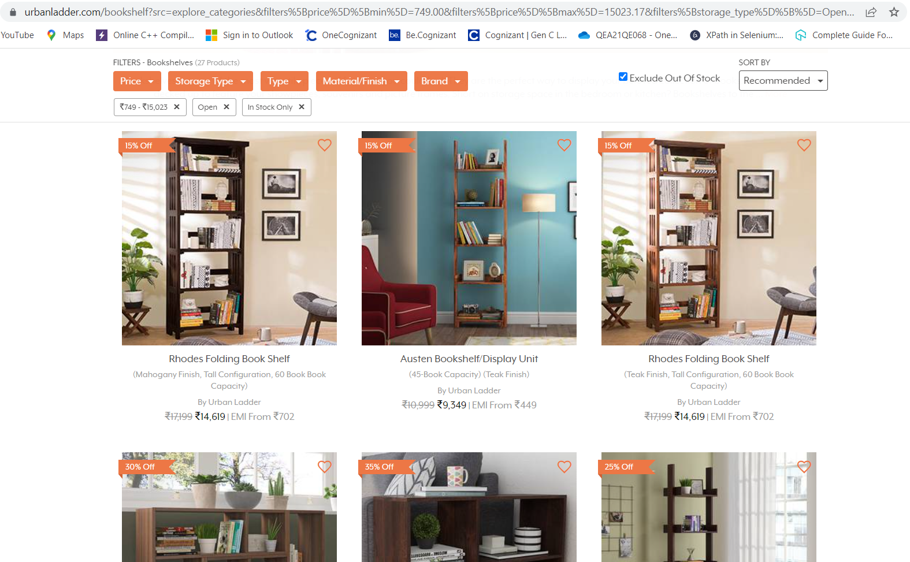

**3.2 REQ_002-** To verify the sub-menu items of brand under ‘By @home’

* Select the ‘By @home’ from the ‘Brand’ menu option.

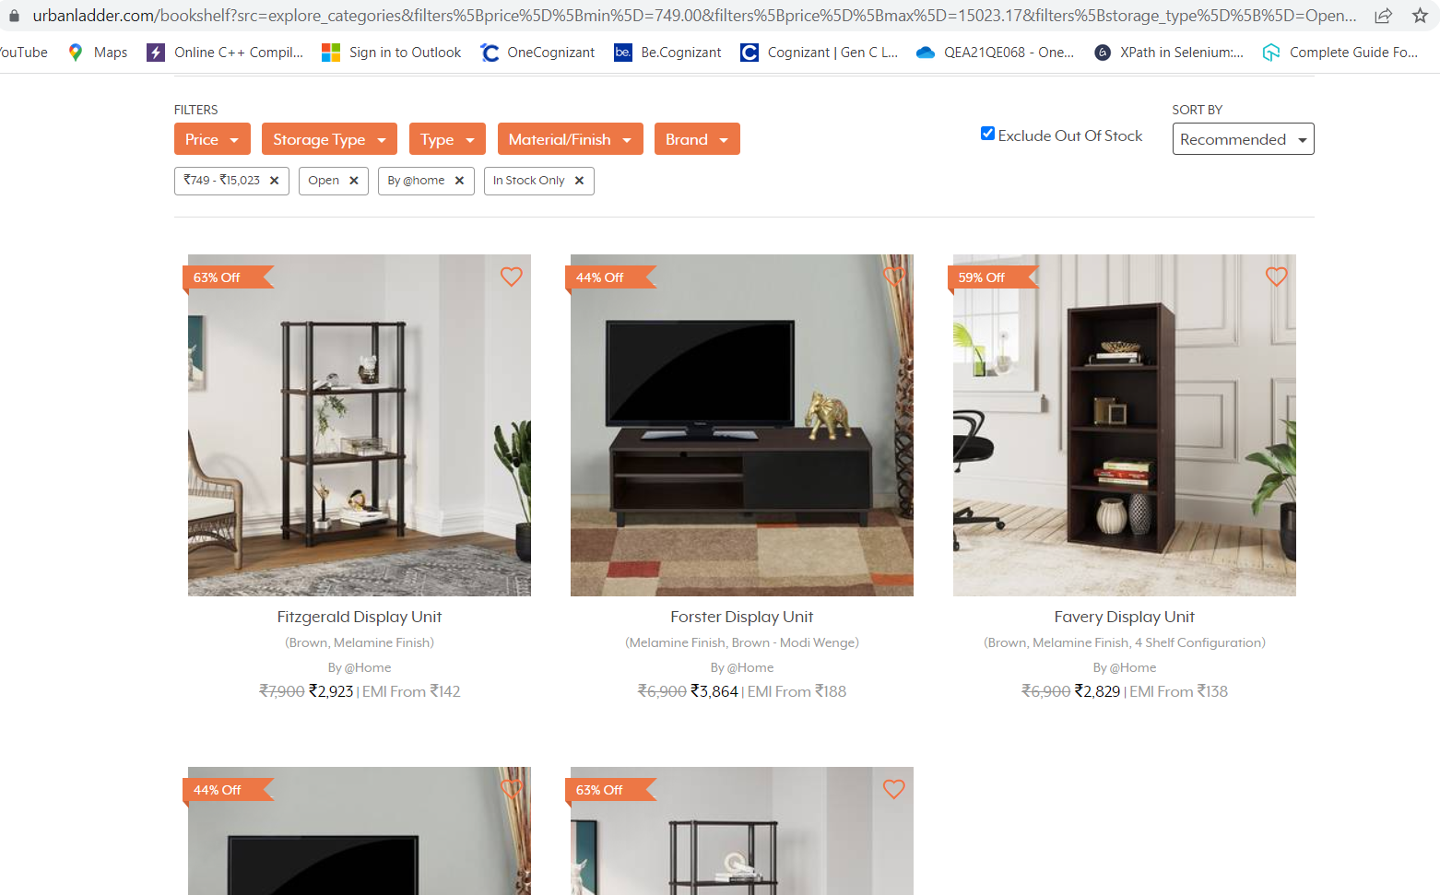

**3.3 REQ_003-** To verify error message from the ‘Gift Cards’ page by providing invalid data for mandatory field.

* Scroll the page up and click on ‘Gift Cards’ Option. (It will take user to ‘Gift Cards’ page).
* Click on the ‘Birthday/Anniversary’ option.
* In the ‘Amount’ textbox, enter the amount as ‘1000’.
* Click ‘NEXT’ Button.
* Fill all the mandatory fields except ‘Recipient’s Email’ textbox.
* Enter invalid value in the ‘Recipient’s Email’ textbox.
* Click ‘CONFIRM’ Button.
* Check whether error message is displayed.

